PROJECT REPORT

ON

“**Seating Arrangement**”



**COMPUTER SCIENCE AND ENGINEERING DEPARTMENT**

**GEETA ENGINEERING COLLEGE**

**NAULTHA, PANIPAT**

**2022-23**

SUBMITTED IN THE PARTIAL FULFILLMENT OF THE REQUIREMENT FOR THE AWARD OF THE DEGREE OF

BACHELOR OF TECHNOLOGY

IN

COMPUTER SCIENCE AND ENGINEERING

**Submitted By: Under the Guidance of:**

Nawaraj Mahato (4919129) Ms. Komal

Niranjan Dhungana (4919130) Assistant Professor (CSE)

Geeta Engineering College

B.TECH CSE 4th year Naultha,Panipat

# DECLARATION

This is to certify that the academic training work entitled **“Seating Arrangement”** which is submitted by our team in partial fulfilment of the requirement for the award of degree B-Tech in Computer Science of Engineering to Geeta Engineering college, Panipat comprises only our original work and due acknowledgement has been in the text to all other material used.

Date:

Nawaraj Mahato (4919129)

Niranjan Dhungana (4919130)

# CERTIFICATE

This is to certify that the Minor Project entitled **“Seating Arrangement”** is a Bonafidde work carried out byMr. **Nawaraj Mahato** Roll No. **4919129** and Mr. **Niranjan Dhungana** Roll No. **4919130** under my guidance and supervision and submitted in partial fulfillment of the award of the B.Tech degree in Computer Science and Engineering. The work embodied in the Minor Project has not been submitted for the award of any other degree or degree or diploma to the best of my knowledge.

**Ms. Komal**

Assistant professor (CSE)

Geeta Engineering College

Panipat

**Mr. Kapil Saini**

Coordinator of Department,

(Computer Science & Engineering)

# ACKNOWLEDGEMENT

We hereby declare that the proposed work presented in the project entitled **“Seating Arrangement”** in fulfillment of the requirement for the award of the Degree of **Bachelor of Technology** in the **Department of Computer Science & Engineering** of **GEETA ENGINEERING COLLEGE, Kurukshetra University Kurukshetra, Haryana** will be an authentic work carried out by us during 7th semester and will be submitted in the stipulated time period.

We further declare that no material of this project has been copied from any known source and submitted before, for the award of any certificate.

Date:

Nawaraj Mahato (4919129)

Niranjan Dhungana (4919130)

# TABLE OF CONTENTS

**Declaration…………………………………………….………………………………………………………………i**

**Certificate……………………………………………………………………………………………………………..ii**

**Acknowledgement………………………………………………………………………………………………..iii**

**Table of Contents............................................................................................................................iv**

**Chapter-1...............................................................Requirements of Project**

**Chapter-2...............................................................Feasibility Study**

**Chapter-3................................................................Implementation**

**Chapter-4................................................................Snap Shots**

**Chapter-5................................................................Conclusion**

**Chapter-6..........................................................References**

**REQUIREMENTS OF PROJECT**

The **“Seating Arrangement”** is a PHP project that can automate the process of exam allotment and seating arrangement. The system was developed using the following languages: PHP, HTML, CSS, JavaScript, MySQLi, and jQuery.

The system facilitates the examination by assigning each student to their respected classes and allocating the seating arrangement to avoid conflict. Most of the time student faces problems finding their assign examination hall, so with this system, it will be easier to manage the location by arranging each hall in a computer-generated way. This is very useful for colleges whereas it can generate a report that concerned the students.

The system has a feature that generates a report automatically during exams at the end of the session or in between the session.

**FEASIBILITY STUDY**

After doing the project Exam Seating Arrangement System, study and analyzing all the existing or required functionalities of the system, the next task is to do the feasibility study for the project. All projects are feasible - given unlimited resources and infinite time.

Feasibility study includes consideration of all the possible ways to provide a solution to the given problem. The proposed solution should satisfy all the user requirements and should be flexible enough so that future changes can be easily done based on the future upcoming requirements.

## **Economical Feasibility**

This is a very important aspect to be considered while developing a project. We decided the technology based on minimum possible cost factor.

* + All hardware and software cost has to be borne by the organization.
  + Overall we have estimated that the benefits the organization is going to receive from the proposed system will surely overcome the initial costs and the later on running cost for system.

## **Technical Feasibility**

This included the study of function, performance and constraints that may affect the ability to achieve an acceptable system. For this feasibility study, we studied complete functionality to be provided in the system, as described in the System Requirement Specification (SRS), and checked if everything was possible using different type of frontend and backend plaformst.

## **Operational Feasibility**

No doubt the proposed system is fully GUI based that is very user friendly and all inputs to be taken all self-explanatory even to a layman. Besides, a proper training has been conducted to let know the essence of the system to the users so that they feel comfortable with new system. As far our study is concerned the clients are comfortable and happy as the system has cut down their loads and doing.

# ****SYSTEM SPECIFICATIONS****

# ****HARDWARE REQUIREMENTS****

**PROCESSOR:** INTEL CORE I3  
**RAM**: 4GB  
**HDD**: 1TB  
**MONITOR**: 15” COLOR MONITOR

# ****SOFTWARE REQUIREMENTS****

**FRONT END**: HTML, CSS  
**BACK END**: PHP, SQL  
**OPERATION SYSTEM**: WINDOWS 7  
**IDE**: XAMPP SERVER

**IMPLEMENTATION**

<?php include('head.php');?>

<?php include('header.php');?>

<?php include('sidebar.php');?>

<?php

date_default_timezone_set('Asia/Kolkata');

$current_date = date('Y-m-d');

$sql_currency = "select * from manage_website";

$result_currency = $conn->query($sql_currency);

$row_currency = mysqli_fetch_array($result_currency);

?>

<div class="page-wrapper">

<div class="row page-titles">

<div class="col-md-5 align-self-center">

<h3 class="text-primary">Dashboard</h3> </div>

<div class="col-md-7 align-self-center">

<ol class="breadcrumb">

<li class="breadcrumb-item"><a href="javascript:void(0)">Home</a></li>

<li class="breadcrumb-item active">Dashboard</li>

</ol>

</div>

</div>

<div class="container-fluid">

<div class="row">

<div class="col-md-4">

<div class="card bg-primary p-20">

<div class="media widget-ten">

<div class="media-left meida media-middle">

<span><i class="ti-bag f-s-40"></i></span>

</div>

<div class="media-body media-text-right">

<?php $sql="SELECT COUNT(*) FROM `tbl_teacher`";

$res = $conn->query($sql);

$row=mysqli_fetch_array($res);?>

<h2 class="color-white"><?php echo $row[0];?></h2>

<p class="m-b-0">Total Teachers</p>

</div>

</div>

</div>

</div>

<div class="col-md-4">

<div class="card bg-pink p-20">

<div class="media widget-ten">

<div class="media-left meida media-middle">

<span><i class="ti-comment f-s-40"></i></span>

</div>

<div class="media-body media-text-right">

<?php $sql="SELECT COUNT(*) FROM `tbl_student`";

$res = $conn->query($sql);

$row=mysqli_fetch_array($res);?>

<h2 class="color-white"><?php echo $row[0];?></h2>

<p class="m-b-0">Total Student</p>

</div>

</div>

</div>

</div>

<div class="col-md-4">

<div class="card bg-danger p-20">

<div class="media widget-ten">

<div class="media-left meida media-middle">

<span><i class="ti-vector f-s-40"></i></span>

</div>

<div class="media-body media-text-right">

<?php $sql="SELECT COUNT(*) FROM `tbl_class`";

$res = $conn->query($sql);

$row=mysqli_fetch_array($res);?>

<h2 class="color-white"><?php echo $row[0];?></h2>

<p class="m-b-0">Total Class</p>

</div>

</div>

</div>

</div>

<div class="col-md-4">

<div class="card bg-warning p-20">

<div class="media widget-ten">

<div class="media-left meida media-middle">

<span><i class="ti-location-pin f-s-40"></i></span>

</div>

<div class="media-body media-text-right">

<?php $sql="SELECT COUNT(*) FROM `tbl_subject`";

$res = $conn->query($sql);

$row=mysqli_fetch_array($res);?>

<h2 class="color-white"><?php echo $row[0];?></h2>

<p class="m-b-0">Total Subject</p>

</div>

</div>

</div>

</div>

</div>

<div class="row page-titles">

<div class="col-md-5 align-self-center">

<h3 class="text-primary">View Exam</h3> </div>

</div>

<div class="card">

<div class="card-body">

<div class="table-responsive m-t-40">

<table id="myTable" class="table table-bordered table-striped">

<thead>

<tr>

<th>Exam Name</th>

<th>Action</th>

</tr>

</thead>

<tbody>

<?php

include 'connect.php';

$sql1 = "SELECT * FROM `exam`";

$result1 = $conn->query($sql1);

while($row = $result1->fetch_assoc()) {

?>

<tr>

<td><?php echo $row['name']; ?></td>

<td>

<a href="view_exam.php?id=<?=$row['id'];?>"><button type="button" class="btn btn-xs btn-danger" ><i class="fa fa-trash"></i></button></a>

</td>

</tr>

<?php } ?>

</tbody>

</table>

</div>

</div>

</div>

</div>

<?php include('footer.php');?>

# SNAP SHOTS

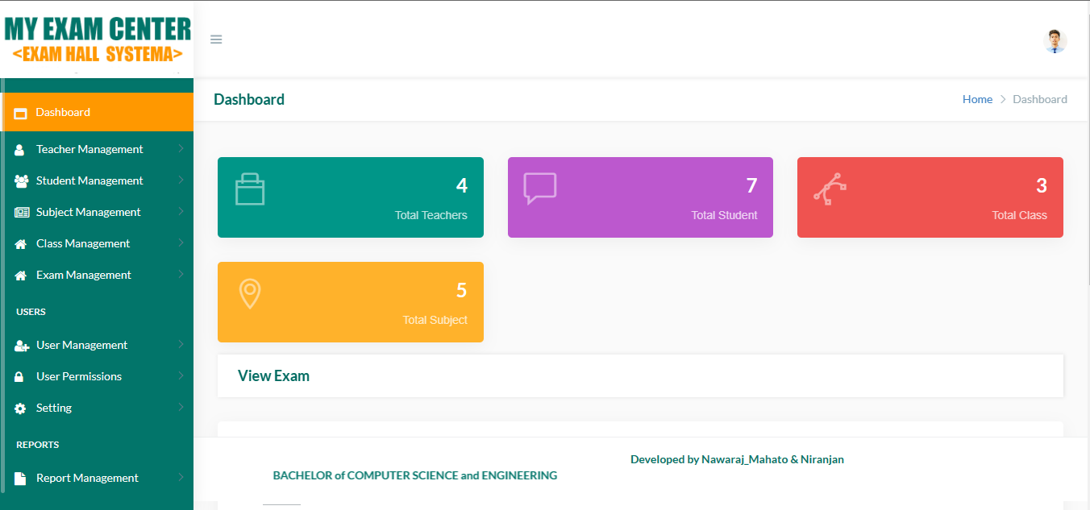

# Conclusion of the Project Exam Seating Arrangement System:

Our project is only a humble venture to satisfy the needs to manage their project work. Several user friendly coding have also adopted. This package shall prove to be a powerful package in satisfying all the requirements of the school. The objective of software planning is to provide a frame work that enables the manger to make reasonable estimates made within a limited time frame at the beginning of the software project and should be updated regularly as the project progresses.

At the end it is concluded that we have made effort on following points…

A description of the background and context of the project and its relation to work already done in the area.

Made statement of the aims and objectives of the project.

The description of Purpose, Scope, and applicability.

We define the problem on which we are working in the project.

We describe the requirement Specifications of the system and the actions that can be done on these things.

We understand the problem domain and produce a model of the system, which describes operations that can be performed on the system.

We included features and operations in detail, including screen layouts.

We designed user interface and security issues related to system.

Finally the system is implemented and tested according to test cases.

# Future Scope of the Project:

In a nutshell, it can be summarized that the future scope of the project circles around maintaining information regarding:

We can add printer in future.

We can give more advance software for Exam Seating Arrangement System including more facilities

We will host the platform on online servers to make it accessible worldwide

Integrate multiple load balancers to distribute the loads of the system

Create the master and slave database structure to reduce the overload of the database queries

Implement the backup mechanism for taking backup of codebase and database on regular basis on different servers

The above mentioned points are the enhancements which can be done to increase the applicability and usage of this project. Here we can maintain the records of Exam and Seats. Also, as it can be seen that now-a-days the players are versatile, i.e. so there is a scope for introducing a method to maintain the Exam Seating Arrangement System. Enhancements can be done to maintain all the Exam , Seats, Student, Roll Number, Rooms.

We have left all the options open so that if there is any other future requirement in the system by the user for the enhancement of the system then it is possible to implement them.In the last we would like to thanks all the persons involved in the development of the system directly or indirectly. We hope that the project will serve its purpose for which it is develop there by underlining success of process.

# References and Bibliography:

Google for problem solving

https://[www.tutorialspoint.com/php/](http://www.tutorialspoint.com/php/)

<http://www.wampserver.com/en/>

<https://www.apachefriends.org/>

<http://www.tutorialspoint.com/mysql/>

httpd.apache.org/docs/2.0/misc/tutorials.html